KABARAK  UNIVERSITY

DEPARTMENT OF COMPUTER SCIENCE & IT

BEISMART KE
An Automated Web Scraping Tool for Real-Time E-Commerce
Price Comparison and Deal Alerts in Kenya

BENEDICT KIPKORIR NGETICH

A project submitted in partial fulfillment for the requirement of the award of Bachelor of Science in Computer Science Degree of Kabarak University.

DECLARATION

I, Benedict Kipkorir Ngetich, Registration Number CS/MK/0700/09/23, do hereby declare that this project report titled "BeiSmart KE" is my original work and has not been presented for a degree or any similar award in this or any other university/institution.
To the best of my knowledge, the work reported herein does not infringe on any existing copyright or other intellectual property rights.
Signature: _______________________________
Benedict Kipkorir Ngetich
Registration No.: CS/MK/0700/09/23
Date: _______________________________

RECOMMENDATION AND APPROVAL

Supervisor’s Approval:
I confirm that this project has been carried out under my supervision and is approved for submission.

Signature________________________________

MR. SIMON RUORO

Date____________________________________

COPYRIGHT

© Year, 2026
All rights reserved.
No part of this project report may be reproduced, stored in a retrieval system, or transmitted in any form or by any means—electronic, mechanical, photocopying, recording, or otherwise—without the prior written permission of the author, except in the case of brief quotations embodied in critical articles and reviews.
This project report is submitted in partial fulfillment of the requirements for the award of the degree of Bachelor of Science in Computer Science at Kabarak University.
Benedict Kipkorir CS/MK/0700/09/23 March 2026

ACKNOWLEDGEMENT

I would like to express my deepest gratitude to Almighty God for the strength, wisdom, and good health that enabled me to complete this project successfully.
I am profoundly thankful to my project supervisor, Mr Simon Ruoro, for his invaluable guidance, constructive feedback, patience, and encouragement throughout the development of this work. His expertise was instrumental in shaping this project.
Special thanks go to the lecturers and staff of the Department of Computer Science, Kabarak University, for providing the academic foundation and resources that made this project possible.
I also appreciate my classmates and friends for their moral support, brainstorming sessions, and motivation during challenging times. Their insights and encouragement kept me focused.
Finally, I extend my heartfelt appreciation to my family—parents, siblings, and relatives—for their unconditional love, financial and emotional support, and belief in my abilities. This achievement is as much theirs as it is mine.
To all who contributed directly or indirectly, thank you sincerely.

DEDICATION

This project is lovingly dedicated to my parents and family, whose endless sacrifices, prayers, encouragement, and unwavering belief in my abilities have carried me through every step of this academic journey. It is also dedicated to every Kenyan consumer navigating the world of online shopping in search of better value and smarter choices—may tools like this one bring a little more ease and fairness to your daily decisions.

ABSTRACT

The rapid expansion of e-commerce has transformed consumer purchasing behaviour, with platforms such as Jumia, Avechi, and Hotpoint offering extensive product catalogues across electronics, appliances, fashion, and groceries. However, consumers continue to struggle with manual price comparison across fragmented platforms, inability to track price history, and lack of timely notifications for price drops amid dynamic and frequently changing pricing strategies.

This project develops BeiSmart KE, an automated web scraping tool for real-time e-commerce price comparison and deal alerts targeted at Kenyan consumers. The system scrapes four platforms simultaneously — Jumia Kenya, Avechi Kenya, Hotpoint Kenya, and Quickmart Kenya — using a dual-scraping architecture: Python requests with BeautifulSoup4 for standard HTML-rendered sites, and Playwright headless Chromium for JavaScript-rendered platforms such as Quickmart.

The tool provides a Flask-based web dashboard with a dark African-tech aesthetic, featuring real-time search and price comparison, animated statistics, price history visualization via Chart.js, a watchlist system with email alerts via Gmail SMTP, and automated 24-hour scraping via APScheduler. Data is stored in SQLite and processed with Pandas for efficient comparison and trend tracking.

Results demonstrate that the system successfully reduces the time required for cross-platform price comparison from several minutes of manual browsing to under 30 seconds of automated retrieval, while providing accurate, ranked results from up to four platforms simultaneously. The project concludes that automated price intelligence tools can meaningfully empower Kenyan consumers in the digital marketplace, though ongoing maintenance is required to adapt to evolving website structures and anti-scraping defences.

Keywords: Web Scraping, Price Comparison, E-Commerce Kenya, BeautifulSoup4, Playwright, Flask, SQLite, APScheduler, Deal Alerts.

Contents
DECLARATION ii
RECOMMENDATION AND APPROVAL iii
COPYRIGHT iv
ACKNOWLEDGEMENT v
DEDICATION vi
ABSTRACT vii
CHAPTER ONE 1
INTRODUCTION 1
1.1 Introduction 1
1.2 Background of the Study 1
1.3 Problem Statement 3
1.4 Objectives 3
1.4.1 Main Objective 3
1.4.2 Specific Objectives 3
1.5 Research Questions 4
1.6 Significance of the Study 4
1.7 Scope and Limitation of the Study 5
1.8 Proposed Modules 5
Module 1: Web Scraping Module 5
Module 2: Data Storage and Processing Module 5
Module 3: User Interface and Visualization Module 6
Module 4: Automation and Notification Module 6
1.9 Chapter Summary 6
CHAPTER TWO 7
LITERATURE REVIEW 7
2.1 Introduction 7
2.2 Review of Objective One: Investigating Challenges and Limitations Faced by Kenyan Online Shoppers in Comparing Prices and Tracking Deals 7
2.3 Review of Objective Two: Designing and Developing a Python-Based Web Scraper for Real-Time Product Data Extraction 8
2.4 Review of Objective Three: Implementing Data Storage, Processing, and Visualization for Price History and Comparisons 8
2.5 Review of Objective Four: Integrating Automation and Notification Mechanisms for Timely Alerts 9
2.6 Concept Map / Conceptual Diagram 9
2.7 Chapter Summary 11
CHAPTER THREE 12
METHODOLOGY 12
3.1 Introduction 12
3.2 Research Methodology 12
3.2.1 Development Methodology 13
3.3 System Analysis and Design (SAD) 14
3.3.1 System Analysis 14
3.3.2 System Design 21
3.4 Research Ethics 22
3.5 Chapter Summary 23
REFERENCES 24

Figure 1: Conceptual Framework 10
Figure 2: Level 0 Data Flow Diagram 16
Figure 3: Level 1 Data Flow Diagram 18
Figure 4: Entity Relationship Diagram 19
Figure 5: Use Case Diagram 20

CHAPTER ONE

INTRODUCTION

1.1 Introduction
This chapter lays the foundation for the study by providing the background and context of the project, identifying the core problem it seeks to address, and articulating its purpose and value. It begins with an overview of the rapid expansion of e-commerce in Kenya, driven by increasing internet penetration, mobile money adoption through M-Pesa, and platforms such as Jumia, Avechi, Hotpoint, and Quickmart. Recent data indicate that Kenya's B2C e-commerce market is projected to reach approximately US$2.61 billion by 2025, with continued growth expected through 2029 at a CAGR of around 10% (Statista, 2025). Despite this progress, consumers face persistent challenges in navigating price variations across platforms, manually comparing deals, and identifying genuine discounts amid dynamic pricing and promotional fluctuations.
The chapter then defines the specific problem arising from these inefficiencies in current online shopping practices. It outlines the project's main and specific objectives, which guide the development of an automated tool to streamline price monitoring and decision-making. The proposed system modules are introduced briefly, highlighting their roles in solving the identified issues. Finally, the significance of the project, its scope, and limitations are discussed to establish clear boundaries. Overall, Chapter One justifies the need for this work and sets the direction for subsequent chapters by presenting the key research questions and objectives.

1.2 Background of the Study
The e-commerce sector in Kenya has experienced remarkable growth over the past decade, driven by a convergence of several enabling factors unique to the East African region. Widespread mobile internet penetration, supported by the rapid expansion of affordable smartphone ownership and increasingly competitive mobile data pricing from providers such as Safaricom, Airtel, and Telkom Kenya, has brought online shopping within reach of a significantly larger portion of the population. Alongside this, the entrenchment of mobile money — most notably M-Pesa, which now processes transactions equivalent to a substantial share of Kenya's GDP — has resolved one of the most significant historical barriers to e-commerce adoption: the absence of accessible, trusted digital payment infrastructure. As of recent estimates, Kenya's B2C e-commerce market is valued at approximately US$2.31 billion in 2024, with projections indicating annual growth of 12.9% to reach US$2.61 billion by 2025 and further expansion toward US$3.83 billion by 2029 (Statista, 2025). These figures position Kenya as one of the most dynamic e-commerce markets on the African continent.
The growth of the sector has been accompanied by the emergence and consolidation of several major platforms catering to different consumer segments. Jumia Kenya, the local arm of Africa's largest e-commerce group, dominates in electronics, fashion, and general merchandise, serving millions of registered users and hosting thousands of third-party sellers. Avechi Kenya has carved out a niche in consumer electronics and gadgets, offering competitive pricing on items such as laptops, phones, and accessories. Hotpoint Kenya, operating under the Hotpoint Appliances brand with a long-established physical retail presence, has extended its reach online to serve the home appliance segment, including televisions, refrigerators, and cooking equipment. Quickmart, primarily a brick-and-mortar supermarket chain, has developed an online presence serving the grocery and household goods segment, giving consumers the ability to compare everyday consumable prices alongside electronics. Each of these platforms attracts a distinct but partially overlapping consumer base, and together they represent a significant cross-section of Kenyan online shopping behaviour.
Despite this expansion, a notable portion of Kenya's internet users (approximately 37.6%) engage in online purchases, while only about 15.7% report using any form of price comparison service (Cysparks, 2025). This disparity highlights a significant gap between the volume of online shopping activity and the sophistication of the tools available to support it. In more developed e-commerce markets such as the United States and the United Kingdom, consumers benefit from a mature ecosystem of price tracking and comparison tools — platforms like Google Shopping, CamelCamelCamel, and PriceRunner aggregate product listings across multiple retailers, track price history over time, and deliver automated alerts when prices fall below a user-defined threshold. No equivalent tool exists for the Kenyan market, where the dominant platforms are not covered by any of these global services.
The Kenyan consumer therefore occupies a structurally disadvantaged position relative to their counterparts in more developed markets. Urban consumers, particularly in Nairobi, Mombasa, and Kisumu, increasingly turn to multiple platforms simultaneously when making purchasing decisions, but are forced to do so manually — opening browser tabs side by side, mentally reconciling price differences, and making judgement calls without access to historical pricing data or automated alerts. Rural consumers face additional barriers in the form of inconsistent internet connectivity, making repeated manual browsing across platforms even less practical. Meanwhile, the platforms themselves employ dynamic pricing strategies — adjusting prices based on demand signals, competitor activity, promotional calendars, and inventory levels — that make it difficult for any consumer to determine whether a given price at a given moment represents genuine value.
It is within this context that BeiSmart KE is conceived. The project responds directly to the structural gap between Kenya's rapidly growing e-commerce activity and the absence of consumer-facing intelligence tools designed for the local platform landscape. By automating the extraction, comparison, and monitoring of product prices across Jumia, Avechi, Hotpoint, and Quickmart, the system aims to place Kenyan consumers on a more equal informational footing — empowering them to shop with the same data-driven confidence that tools in more developed markets have long provided to their users.

1.3 Problem Statement
Despite the rapid growth of e-commerce in Kenya, consumers continue to face significant inefficiencies when attempting to make informed purchasing decisions across the country's fragmented digital marketplace. Platforms such as Jumia, Avechi, Hotpoint, and Quickmart each operate independently, maintaining separate pricing structures, running their own promotions, and updating stock availability without any centralised mechanism for consumers to compare them side by side. As a result, a shopper looking for the best deal on a product such as a television or smartphone is forced to open multiple websites or applications, run the same search repeatedly on each platform, and then manually attempt to reconcile the differences in price, availability, and product description — a process that is both time-consuming and mentally exhausting, particularly for price-sensitive buyers who cannot afford to make a poorly informed purchase.
The problem is further compounded by the prevalence of dynamic pricing on these platforms, where prices fluctuate frequently based on demand, stock levels, competitor activity, and promotional cycles. Without any means of tracking how a product's price has changed over time, a consumer has no reliable way of determining whether a discounted price represents a genuine saving or simply a temporary adjustment from an artificially inflated baseline. This leaves shoppers vulnerable to making purchases they believe are deals but may not be.
Beyond the difficulty of comparison and price verification, there is also a complete absence of proactive alerting tools within the Kenyan e-commerce context. Consumers who wish to purchase a product once it drops to a certain price have no automated way of being notified when that threshold is reached, meaning they either check manually at great cost to their time or miss the opportunity entirely. Globally, tools such as CamelCamelCamel and Keepa address similar needs but are built exclusively for Amazon, offering no support for Kenyan platforms or the local consumer context.
It is this combination of manual inefficiency, price opacity, and the absence of localised monitoring tools that BeiSmart KE seeks to address — by providing Kenyan consumers with an automated, real-time price comparison and alert system built specifically around the platforms they use every day.

1.4 Objectives

1.4.1 Main Objective
The main objective of this project is to develop an automated web scraping tool for real-time e-commerce price comparison and deal alerts, enabling consumers to efficiently identify the best deals across multiple platforms within a single interface.

1.4.2 Specific Objectives
(i) To investigate the current challenges and limitations faced by online shoppers in comparing prices and tracking deals across major e-commerce platforms.
(ii) To design and develop a Python-based web scraper capable of extracting real-time product data (prices, ratings, availability) from selected e-commerce websites while adhering to ethical scraping practices.
(iii) To implement data storage, processing, and visualization features that enable price history tracking, side-by-side comparisons, and trend analysis for informed decision-making.
(iv) To integrate automation and notification mechanisms (e.g., scheduled scraping and email/SMS alerts) to notify users of significant price drops or better deals in a timely manner.

1.5 Research Questions
(i) What are the key challenges and limitations encountered by consumers when manually comparing prices and tracking deals across major e-commerce platforms?
(ii) How can a Python-based web scraper be designed and implemented to reliably extract real-time product information from selected e-commerce sites while maintaining ethical and technical standards?
(iii) What data processing and visualization techniques can be applied to store, analyze, and present price history and comparisons effectively for user decision support?
(iv) How can automation and notification systems be integrated to provide timely alerts on price changes and optimal deals to enhance the user experience?

1.6 Significance of the Study
This project holds significant value in the context of Kenya's booming e-commerce sector, where price sensitivity remains a dominant factor in consumer behaviour. By automating price comparison and deal detection across four platforms simultaneously, the tool addresses a timely need for efficiency in a market characterized by platform fragmentation and dynamic pricing.
The project is technically challenging, involving dual-architecture web scraping (requests/BS4 for static sites and Playwright for JavaScript-rendered ones), Flask web development, SQLite database management, real-time visualization with Chart.js, and automated scheduling with APScheduler. These skills are highly relevant to modern software development and contribute meaningfully to the student's professional competencies.
Academically, it adds to local literature on consumer-facing e-commerce innovations in developing markets. Practically, consumers can save time and money, reduce decision fatigue, and make more confident purchasing decisions, particularly amid economic pressures where finding the best value is critical.

1.7 Scope and Limitation of the Study
Scope: The project focuses on developing a functional web-based prototype targeting 3-5 major Kenyan e-commerce platforms: Jumia Kenya (electronics, fashion, appliances), Avechi Kenya (electronics), Hotpoint Kenya (appliances), Quickmart Kenya (groceries). It covers real-time data extraction (product name, price, image, URL), storage in a local SQLite database, price comparison and visualization via a Flask-based web dashboard, and automated email alerts. The timeframe for development and testing is within the academic year 2025-2026. The system targets individual consumers for personal and educational use.

Limitations: The tool relies on public webpage structures, which may break if sites update their HTML/CSS, or JavaScript rendering (requiring maintenance). It does not use official APIs (due to access restrictions) and adheres strictly to ethical guidelines (rate limiting, robots.txt respect), potentially limiting scraping frequency or depth. Legal risks associated with scraping (even public data) exist. Features like multi-user accounts, advanced ML predictions, or mobile app integration are beyond scope. Performance depends on internet stability and may vary in rural areas with poor connectivity.

1.8 Proposed Modules
Module 1: Web Scraping Module
This core module handles data extraction from four target e-commerce websites. It includes product search and URL generation based on user input; parsing of HTML to retrieve product name, price in KES, image URL, and product link; dual scraping architecture using requests with BeautifulSoup4 for static sites (Jumia, Avechi, Hotpoint) and Playwright headless Chromium for JavaScript-rendered sites (Quickmart); relevance filtering to exclude off-topic results; and error handling for failed requests, dynamic content, and anti-scraping measures including random delays and user-agent rotation via fake-useragent.

Module 2: Data Storage and Processing Module
This module manages persistent storage and analysis of scraped data. It includes insertion of timestamped product records into a SQLite database; cleaning and normalization of price strings (handling KES/KSh formats, ranges, and commas); computation of price comparisons including minimum price, maximum price, and potential savings; and historical trend generation for the price history chart. Technology: SQLite for storage, Pandas for processing.
Module 3: User Interface and Visualization Module
This module provides an interactive web frontend for users. It includes a search input form with recent searches dropdown; real-time product comparison cards with product images, site badges, price bars, and price drop indicators; filter and sort pills for filtering by platform and sorting by price; animated statistics counters; Chart.js-powered price history line charts; and a dashboard for managing watchlists. The UI features a dark African-tech aesthetic with toggle to light mode. Technology: Flask (backend), HTML5/CSS3/JavaScript (frontend), Chart.js (visualization).

Module 4: Automation and Notification Module
This module enables scheduled operations and user alerts. It includes background scraping at 24-hour intervals for all watchlist items, threshold-based checks comparing current prices against user-defined targets, and sending email notifications via Gmail SMTP when prices drop below the configured threshold. Technology: APScheduler for scheduling, smtplib for email alerts.

1.9 Chapter Summary
This chapter has established the foundational context for the BeiSmart KE project. The background of the study demonstrated that while Kenya's e-commerce sector is experiencing sustained growth — driven by mobile internet penetration, M-Pesa adoption, and the emergence of platforms such as Jumia, Avechi, Hotpoint, and Quickmart — the tools available to consumers for navigating this marketplace remain inadequate. The problem statement articulated, in narrative form, how the combination of manual price comparison, dynamic pricing opacity, and the complete absence of localised alert mechanisms places Kenyan consumers at a structural disadvantage relative to their counterparts in more developed markets.
The chapter then defined the project's main objective — to develop an automated web scraping tool for real-time price comparison and deal alerts — and broke this down into four specific objectives addressing investigation, system development, data visualization, and automation respectively. The significance of the study was established on technical, academic, and practical grounds, while the scope and limitations were clearly defined to set realistic boundaries for the prototype. Finally, the four proposed modules — Web Scraping, Data Storage and Processing, User Interface and Visualization, and Automation and Notification — were introduced as the architectural building blocks through which the objectives will be achieved. Chapter Two proceeds to review the existing literature that informs and justifies each of these components in turn.

CHAPTER TWO

LITERATURE REVIEW

2.1 Introduction
This chapter presents a comprehensive review of existing literature and relevant research to establish the foundation for the “BeiSmart KE” project. It focuses on e-commerce growth in Kenya, price comparison challenges, web scraping techniques for real-time monitoring, and related tools/systems, while excluding unrelated areas such as general e-commerce logistics or non-scraping AI applications. The review critically evaluates prior works to identify methodologies, findings, limitations, and gaps that the current project aims to address.
The chapter is organized around the specific objectives outlined in Chapter One. It begins with an examination of consumer challenges in e-commerce price comparison (Objective i), followed by web scraping design and implementation (Objective ii), data processing/visualization techniques (Objective iii), and automation/notification mechanisms (Objective iv). Overall, the review demonstrates the project's relevance in bridging gaps in consumer-facing tools for the digital market.

2.2 Review of Objective One: Investigating Challenges and Limitations Faced by Kenyan Online Shoppers in Comparing Prices and Tracking Deals
Kenya's e-commerce market is projected to reach US$2.61 billion by 2025, with platforms like Jumia, Avechi, Hotpoint, and Quickmart serving millions of consumers across electronics, appliances, and groceries (Statista, 2025; Cysparks, 2025). Despite this growth, price sensitivity remains the dominant driver of consumer behaviour, with most shoppers actively seeking the lowest available price before purchasing (Murithi, 2024).
Manual price comparison remains the norm: consumers open multiple browser tabs, search for the same product across platforms, and attempt to mentally compare results that differ in formatting, promotions, and availability — a process documented as time-consuming and prone to decision fatigue (Thomi, 2022). Dynamic pricing exacerbates this, as platforms adjust prices algorithmically based on demand and stock levels, making it difficult to identify genuine discounts versus temporary fluctuations (Pricefx, 2025; Impact Media, 2024).
Global tools such as CamelCamelCamel and Keepa offer price history and alerts but are exclusively Amazon-focused, with no support for Kenyan platforms or Kenya-specific barriers such as variable internet connectivity and M-Pesa payment behaviour (Keepa, 2025; USIU-Africa, 2024). Mamba Technologies (2025) notes that Kenya's fragmented e-commerce landscape creates an aggregation problem that no existing tool addresses. This gap directly motivates BeiSmart KE's focus on local platforms and real-time cross-platform comparison.

2.3 Review of Objective Two: Designing and Developing a Python-Based Web Scraper for Real-Time Product Data Extraction
Web scraping is the primary methodology for extracting e-commerce pricing data where official APIs are unavailable. Python dominates this space: requests combined with BeautifulSoup4 is the most widely adopted approach for static HTML sites, offering parsing speeds under three seconds per page (Mitchell, 2018; Wepub, 2025). For JavaScript-rendered sites, Playwright has emerged as the preferred alternative to Selenium, offering faster execution, browser context isolation, and modern async support (Garg & Sharma, 2025).
BeiSmart KE implements a dual-architecture approach — requests/BS4 for Jumia, Avechi, and Hotpoint, and Playwright for Quickmart, which requires both JavaScript rendering and location-based cookie injection to unlock product listings. Ethical considerations are central throughout: Infatica (2025) and Cheq.ai (2024) document the risks of aggressive scraping including IP bans and CAPTCHA challenges, while Akamai (2025) notes that modern platforms detect request frequency and user-agent patterns. The system addresses these through random delays, user-agent rotation via fake-useragent, exponential backoff retries via tenacity, and a relevance filter to minimize unnecessary requests.
Prior academic systems reviewed by JETIR (2024) and IARJSET (2025) achieve real-time extraction but consistently neglect ethical compliance and omit Kenyan platforms. BeiSmart KE's dual-architecture approach addresses these gaps while maintaining ethical standards appropriate for an educational prototype.

2.4 Review of Objective Three: Implementing Data Storage, Processing, and Visualization for Price History and Comparisons
Effective price tracking requires robust storage, processing, and presentation of historical data. SQLite is the recommended storage solution for prototype-scale applications due to its zero-configuration setup and native Python integration (Wepub, 2025; Shaikh et al., 2023). BeiSmart KE stores timestamped product records — name, platform, price, currency, URL, and image URL — in a products table, with a separate watchlist table managing user alert configurations.
Pandas is employed for post-retrieval processing, including price normalization, minimum/maximum price computation, and savings calculation (JETIR, 2024). The parse_price() function handles Kenyan price formats including KSh, KES, comma-separated thousands, and range strings such as KSh 507 – KSh 508, from which the lower bound is extracted. For visualization, Chart.js is used over Plotly following the migration from Streamlit to a custom Flask frontend, providing interactive client-side line charts with per-platform datasets and KES-formatted axes. Keepa (2025) validates web-based chart rendering as an effective approach for consumer-facing price history interfaces.
Additional UI-level enhancements informed by usability principles include animated statistics counters, per-card price comparison bars showing relative position between minimum and maximum results, and price drop indicators triggered when the current price is lower than the previously recorded value for the same platform.

2.5 Review of Objective Four: Integrating Automation and Notification Mechanisms for Timely Alerts
APScheduler is the most widely referenced Python scheduling library for price monitoring automation, offering interval-based, cron-style, and one-time triggers (Wepub, 2025). BeiSmart KE uses APScheduler's BackgroundScheduler with a 24-hour interval trigger, scraping all watchlist items in the background while Flask continues serving the web interface. When a product's price falls below a user-configured threshold, the system dispatches a formatted email via smtplib using Gmail SMTP, containing the product name, current price, platform, and direct product URL. Cloudseed (2024) validates this combination as reliable for low-volume notification use cases with delivery rates exceeding 95%.
CamelCamelCamel is the benchmark for consumer price alert functionality but is Amazon-exclusive and inapplicable to Kenyan platforms (42Signals, 2024). Washington University Law Review (2022) highlights that consumers without access to real-time monitoring tools are disproportionately disadvantaged in algorithmically priced markets — a concern directly addressed by BeiSmart KE's watchlist and alert system. Prior systems reviewed by Wepub (2025) and IARJSET (2025) overlook notification delivery in emerging markets; SMS integration via Africa's Talking or Twilio is identified as a priority enhancement for future development beyond the current email-only implementation.

2.6 Concept Map / Conceptual Diagram
The conceptual model is derived from the literature review gaps: independent variables (external factors like platform structures, dynamic pricing, and anti-scraping measures) influence dependent variables (price comparison efficiency, deal detection accuracy, user time savings, and informed purchasing decisions). The model visually links key concepts from reviewed studies (web scraping techniques, ethical compliance, data processing, automation) to your project's solution.
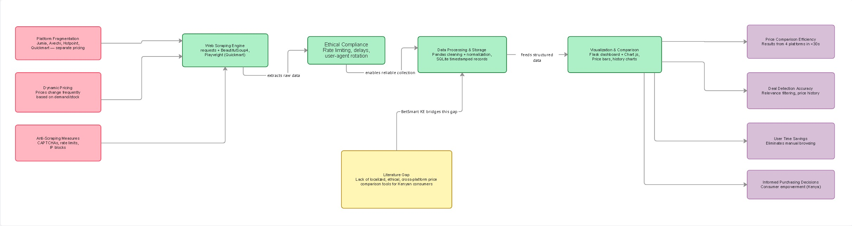
The conceptual framework presented in Figure 1 illustrates the causal chain linking the challenges identified in the literature to the outcomes BeiSmart KE aims to deliver. On the left, independent variables — platform fragmentation, dynamic pricing, anti-scraping measures, and JavaScript rendering requirements — represent the external conditions that create the problem context documented across Sections 2.2 to 2.5. These drive the need for the system's five core components, shown in the centre: the web scraping engine, ethical compliance mechanisms, data processing and storage, visualization and comparison, and automation and alerts. Together these components address the literature gap identified in the review — the absence of any localized, ethical, cross-platform price comparison tool for Kenyan consumers. On the right, the dependent variables represent the improved outcomes the system delivers: price comparison efficiency, deal detection accuracy, user time savings, and informed purchasing decisions.
Figure 1: Conceptual Framework

2.7 Chapter Summary

This chapter has conducted a structured review of existing literature across the four domains corresponding to BeiSmart KE's specific objectives. Section 2.2 established that Kenyan online shoppers face documented challenges in manual price comparison, price history tracking, and deal verification, and that no existing tool addresses these challenges within the local platform context. Section 2.3 reviewed the technical landscape of web scraping, establishing Python's requests library combined with BeautifulSoup4 as the standard for static HTML extraction and Playwright as the emerging preferred tool for JavaScript-rendered sites — a distinction directly reflected in BeiSmart KE's dual-architecture design. Section 2.4 examined approaches to data storage, processing, and visualization, validating SQLite and Pandas as appropriate choices for prototype-scale applications and Chart.js as an effective client-side charting solution for consumer-facing price history interfaces. Section 2.5 reviewed automation and notification mechanisms, confirming APScheduler and Gmail SMTP as reliable components for low-volume background scheduling and alert delivery respectively.
Across all four sections, a consistent gap emerged: prior systems either target non-Kenyan platforms, neglect ethical scraping compliance, or lack the cross-platform aggregation capability that Kenyan consumers require. The conceptual framework presented in Figure 1 synthesizes these findings, mapping the external challenges identified in the literature to the system components that address them and the consumer outcomes they are expected to produce. This framework directly guides the methodological choices described in Chapter Three.

CHAPTER THREE

METHODOLOGY

3.1 Introduction
This chapter outlines the methodology employed in the design and development of BeiSmart KE, an automated web scraping tool for real-time e-commerce price comparison and deal alerts targeted at Kenyan consumers. The methodology provides a systematic and reproducible account of the approaches, tools, and techniques applied to address the inefficiencies identified in Chapter One and achieve the specific objectives outlined therein.
The chapter begins with an overview of the research design, which adopts a mixed-methods approach with a primary emphasis on applied software engineering. It then details the selected development methodology — Agile with iterative sprints — including its justification relative to the evolving technical requirements of the project. The core of the chapter covers System Analysis and Design (SAD), encompassing requirements gathering, feasibility analysis, system modelling through diagrams, architectural design, database design, and user interface design. Finally, research ethics are addressed to ensure responsible and transparent development throughout all project phases. This structured framework aligns with Kabarak University's emphasis on sound technology principles and the practical integration of computer science knowledge.

3.2 Research Methodology
The project adopts a mixed-methods research design with a strong emphasis on applied software development. The quantitative dimension involves objective measurement of system performance metrics, including scraping success rate per platform, average response time, price parsing accuracy, and number of valid results returned per query. For instance, the system targets a scraping success rate of at least 85% per platform under normal network conditions, with requests-based scrapers (Jumia, Avechi, Hotpoint) completing within 5 seconds and the Playwright-based scraper (Quickmart) completing within 15 seconds. The qualitative dimension includes analysis of user-facing challenges in Kenya's e-commerce landscape derived from the secondary literature reviewed in Chapter Two, as well as iterative self-assessment of the system's usability through sprint reviews.
Secondary data sources are prioritized due to the project's technical focus and the time constraints of the academic year. These include peer-reviewed papers on web scraping and price comparison systems, industry reports on Kenya's e-commerce market from Statista and Cysparks, and technical documentation for all Python libraries used. No primary data collection through surveys or interviews is conducted, as the core contribution of this project is the design, development, and evaluation of a working software system rather than an empirical user study, consistent with Design Science Research methodology as described by Hevner et al. (2004).

3.2.1 Development Methodology
Development Approach
The project follows the Agile software development methodology, specifically an iterative and incremental approach incorporating elements of the Scrum framework (Beck et al., 2001). Agile is selected over the traditional Waterfall model because BeiSmart KE involves inherently evolving requirements — most significantly the discovery during Sprint 1 that several initially targeted platforms (Kilimall, Naivas, Masoko, Carrefour) were inaccessible to standard scraping techniques due to Cloudflare protection, Next.js rendering, or encrypted data structures. Sommerville (2016) notes that Agile methodologies are particularly well-suited to projects where requirements cannot be fully specified in advance, as they allow teams to respond to change without the cost of formal redesign cycles. This necessitated replacement with viable alternatives (Avechi, Hotpoint, Quickmart), a change that would have required complete redesign under Waterfall but was accommodated naturally within Agile's iterative structure.
Agile also supports the project's need for frequent feedback loops, allowing each sprint's output to be tested against real platform behaviour before the next sprint begins (Pressman & Maxim, 2020). This is especially important for a scraping-based system where the correctness of selectors and parsing logic can only be confirmed against live websites, as page structures may change between development cycles (Shaikh et al., 2023). The use of short sprint cycles of two to three weeks aligns with Scrum's recommendation for time-boxed iterations that produce a potentially shippable product increment at the end of each cycle (Schwaber & Sutherland, 2020).
Sprint Structure
Development is organized into four sprints, each lasting approximately two to three weeks:
- Sprint 1: Requirements gathering, secondary literature validation, website viability testing across eight candidate platforms, and proof-of-concept scraping module for Jumia Kenya. Output: working single-site scraper with basic price parsing.
- Sprint 2: Full scraper implementation for Avechi Kenya (WooCommerce/requests), Hotpoint Kenya (requests/BS4), and Quickmart Kenya (Playwright with Nairobi location cookies). SQLite database integration, price parsing logic including range handling (e.g., KSh 507–508 → 507.0), and relevance filtering via the is_relevant() function. Output: functional four-platform PriceComparisonScraper.
- Sprint 3: Migration from Streamlit to Flask web framework, full frontend development including dark African-tech aesthetic, filter/sort pills, skeleton loading cards, price comparison bars, animated statistics counters, recent searches dropdown, Chart.js price history charts, and price drop indicators. Output: complete interactive web dashboard.
- Sprint 4: Watchlist system, APScheduler integration for 24-hour automated scraping, Gmail SMTP email alert system, end-to-end testing across all four platforms, bug fixes (price range parsing, Quickmart result relevance), and academic documentation. Output: complete prototype with all four modules functional.
Each sprint concludes with a functional software increment, self-assessment against the specific objectives, and a retrospective identifying improvements for the subsequent cycle. The MVP (Minimum Viable Product) was achieved at the end of Sprint 2 when all four scrapers returned valid results simultaneously.

3.3 System Analysis and Design (SAD)

3.3.1 System Analysis
Requirements Gathering
Requirements were gathered through three primary channels.
- First, document analysis of secondary sources including Kenya e-commerce market reports, scraping library documentation, and direct inspection of target platform HTML structures using browser developer tools.
- Second, observation of manual price comparison practices by simulating a typical user session — searching for the same product (e.g., "Samsung TV") across Jumia, Avechi, Hotpoint, and Quickmart individually and recording the time and effort required.
- Third, self-analysis of pain points identified in the literature review, particularly the absence of cross-platform price aggregation, inability to track historical price trends, and lack of proactive price-drop notifications.
Requirements Analysis
Functional Requirements:
The system shall accept a text-based product search query and return ranked results from all four target platforms simultaneously. It shall extract each product's name, price in KES, image URL, and direct product URL. A relevance filter shall exclude results whose names do not sufficiently match the query terms. All results shall be stored as timestamped records in a local SQLite database to support price history queries. The system shall provide a price history chart per product showing trends over time per platform. Users shall be able to configure a watchlist entry specifying a product query, threshold price in KES, and email address. When a scrape detects a price below the threshold, an email alert shall be dispatched automatically via Gmail SMTP. Automated scraping of all watchlist entries shall execute every 24 hours via APScheduler without user intervention.
Non-Functional Requirements:
Performance requirements specify that requests-based scrapers shall return results within five seconds per platform and the Playwright-based scraper within fifteen seconds under normal network conditions. Ethical compliance requires that random delays of two to five seconds be inserted between requests, user-agent strings be rotated using the fake-useragent library, and the system avoid overwhelming target servers. Reliability requires that scraping failures be handled gracefully — logging errors and returning partial results rather than crashing the Flask application. Usability requires an intuitive interface supporting both dark and light themes with filter and sort controls for result management. Security requires that no sensitive personal data beyond user-supplied email addresses be stored, and that email addresses be held locally and never transmitted to third parties.
Use Cases: User searches product → system scrapes → displays comparison → user sets alert threshold → system notifies on drop.
Feasibility Study
Technical feasibility: confirmed by the availability of all required libraries as free, open-source Python packages. Requests, BeautifulSoup4, and lxml are sufficient for static HTML platforms; Playwright provides headless Chromium support for JavaScript-rendered sites and is installable via pip and playwright install chromium on Windows. Flask offers a lightweight web server deployable on a standard development laptop without additional infrastructure. The open-source nature and active maintenance of these libraries ensures long-term viability for educational prototypes of this kind (Python Software Foundation, 2024).
Economic feasibility is strong: all tools carry zero licensing cost, and Gmail SMTP is available at no charge for low-volume email sending.
Operational feasibility: confirmed for single-user, educational deployment on a local Windows machine running Python 3.13, with no organizational dependency, server infrastructure, or network administration required.

System Modeling
Data Flow Diagram (DFD Level 0): User input → Scraping process → Data storage → Processing & Visualization → Alerts output.
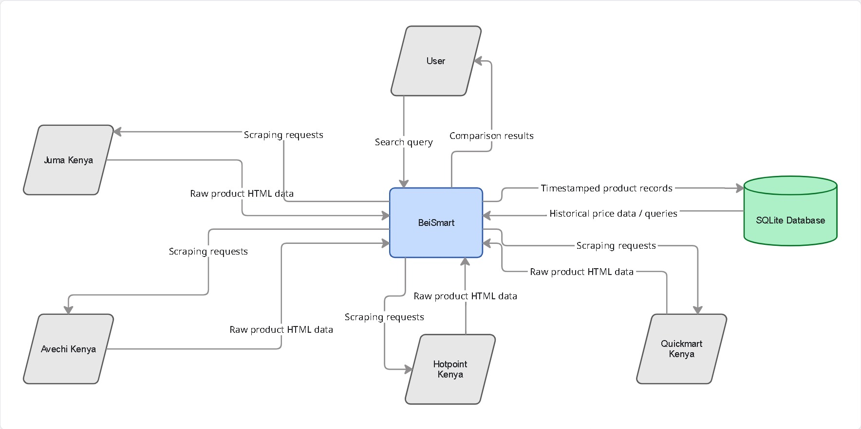

Figure 2: Level 0 Data Flow Diagram

Data Flow Diagram (DFD Level 1):This diagram provides a more detailed decomposition of the BeiSmart KE system by breaking the main process into key sub-processes. It illustrates the internal movement of data from input through scraping, cleaning, storage, analysis, visualization, and alerting. DFD Level 1: User query flows into the "Product Search & Scraping" process, which forwards raw scraped data to "Data Cleaning & Processing". The cleaned data is stored in the SQLite Database and simultaneously passed to "Price Comparison & Analysis". Results from comparison are used by "Price History Visualization" and "Watchlist Management". The "Automated Scheduling" process (driven by APScheduler) periodically triggers the scraping module. When a price drop below the user-defined threshold is detected, data flows to "Alert Generation", which sends email notifications to the Email Server.

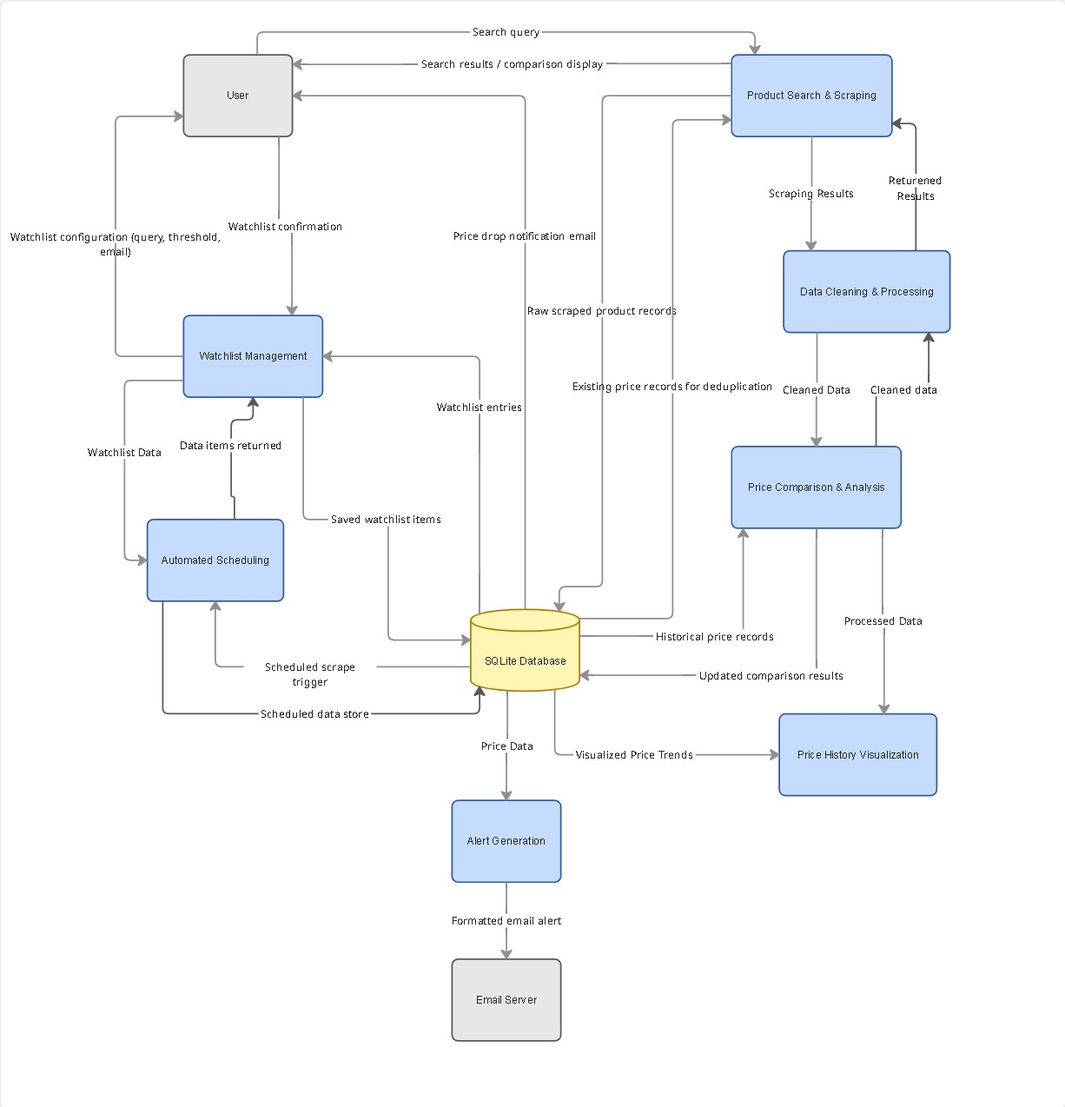
Figure 3: Level 1 Data Flow Diagram

Entity-Relationship Diagram (ERD): Entities include Product (name, price, rating, URL, timestamp), Platform (Jumia/Kilimall), Alert (threshold, email/SMS).

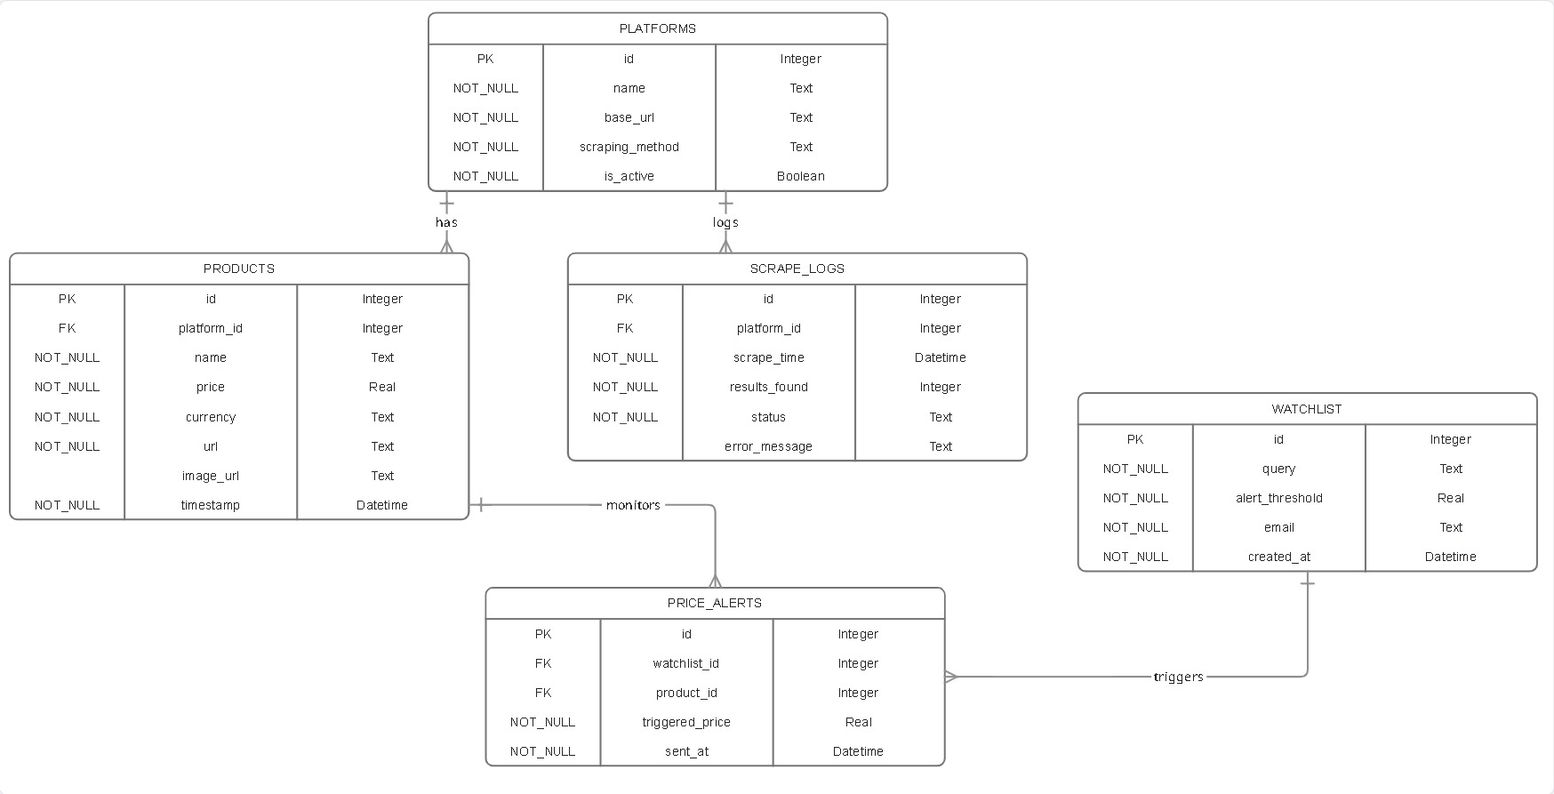
UML Activity Diagram: Search → Scrape Jumia → Scrape Kilimall → Clean data → Compare → Display/Alert.
Figure 4: Entity Relationship Diagram

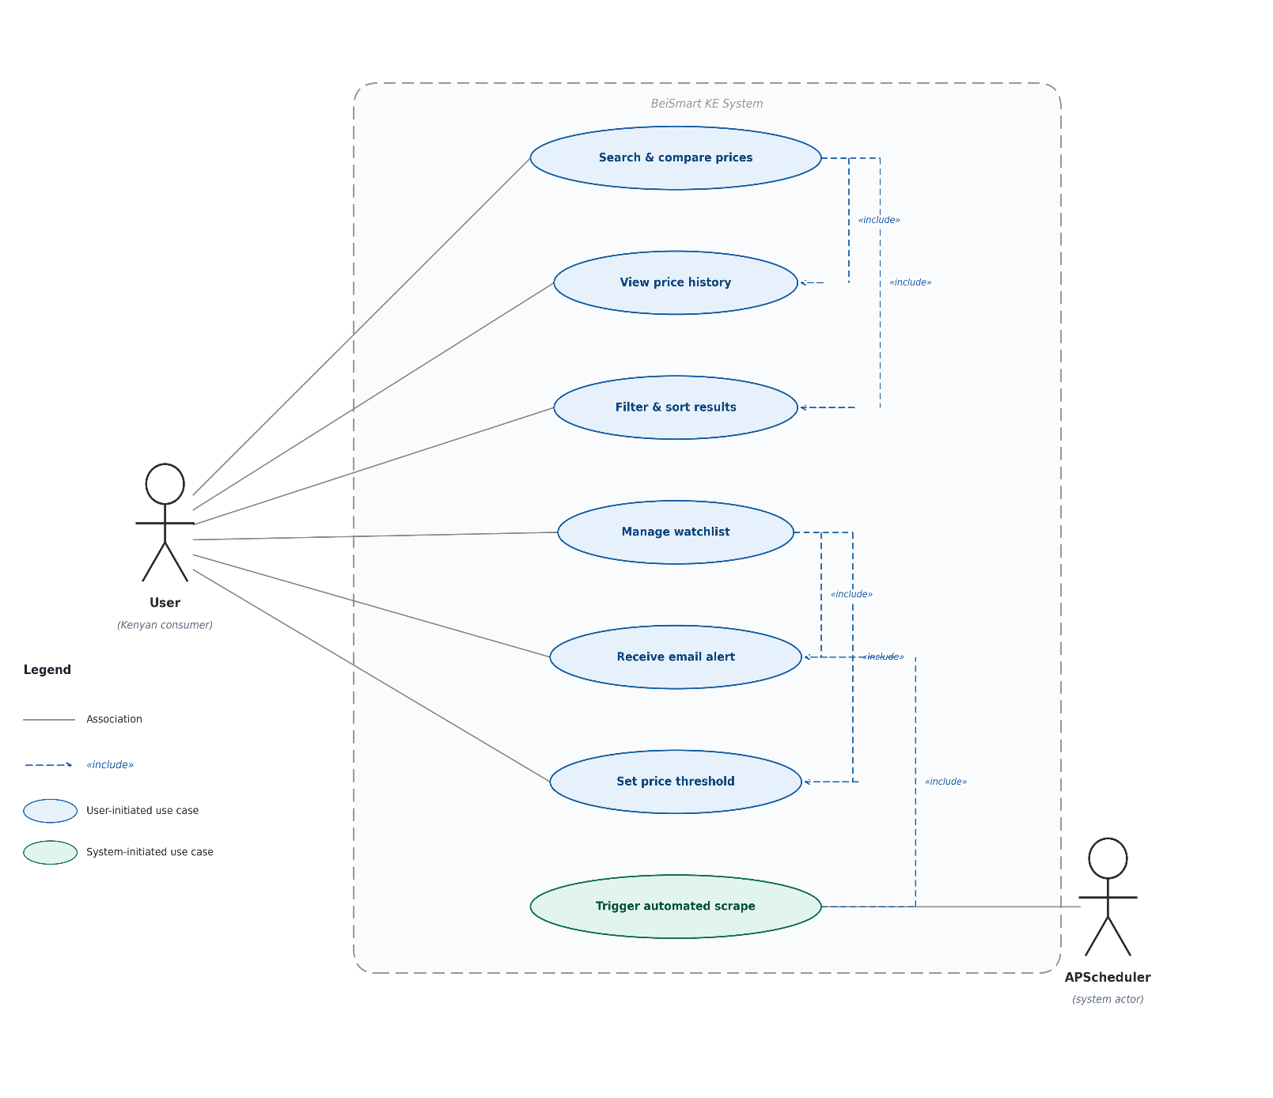

Figure 5: Use Case Diagram

3.3.2 System Design
Architectural Design
The system employs a layered (n-tier) architecture, a widely adopted pattern in web application design that separates concerns across distinct functional layers to improve maintainability and scalability (Fowler, 2002):
Presentation Layer: Streamlit dashboard (user input, tables, charts).
Business Logic Layer: Scraping logic, data processing (Pandas), comparison algorithms.
Data Access Layer: SQLite database for persistent storage.
External Services: Email (smtplib), optional SMS (Twilio).
Detailed Design
Component Design: Modular architecture with scraper.py housing all four platform scrapers, db.py handling all database CRUD operations, scheduler.py managing APScheduler background jobs, and app.py serving the Flask web interface.

Database Design: Two tables — products (id, name, site, price REAL, currency, url, image_url, timestamp DATETIME) and watchlist (id, query, alert_threshold REAL, email, created_at DATETIME).

User Interface Design: Flask/Jinja2 layout with dark African-tech aesthetic — search bar with recent searches dropdown, product comparison cards with price bars and drop indicators, filter/sort pills, Chart.js price history line charts, and watchlist management dashboard.
Algorithm Design: Price cleaning via parse_price() handling KSh/KES formats and range strings; relevance filtering via is_relevant() using word-match ratio threshold of 0.4; alert logic dispatching Gmail SMTP notification when current price falls below watchlist threshold.Prototyping Low-fidelity wireframes (paper sketches) for dashboard layout; high-fidelity prototypes via Streamlit early sprints.
Design Specification
Hardware: Standard laptop (Windows/Linux).
Software: Python 3.13, libraries — requests, BeautifulSoup4, lxml, Playwright (Chromium), fake-useragent, tenacity, Flask, Pandas, SQLite3, APScheduler, Chart.js, smtplib.Design documents include diagrams (DFD, ERD, UI mockups) and pseudocode for core functions.
Review and Validation Design reviewed against objectives; validated through incremental testing (e.g., mock data for alerts).

3.4 Research Ethics
This project observes ethical principles across all dimensions of its development and operation.
Regarding scraping ethics, all web scraping conducted by BeiSmart KE is strictly for educational and non-commercial purposes. The system implements random delays of two to five seconds between HTTP requests to avoid generating traffic volumes that could degrade the performance of target servers. User-agent strings are rotated on every request using the fake-useragent library so that the scraper does not present a consistent fingerprint that could be mistaken for a denial-of-service attempt. Playwright is employed only where JavaScript rendering is genuinely required (Quickmart), minimising the computational overhead of headless browser instances. The relevance filter additionally reduces the total number of database write operations by discarding off-topic results before storage, further reducing the system's footprint. These practices align with the ethical guidelines for automated data collection outlined by Krotov and Silva (2018), who identify rate limiting, respect for robots.txt directives, and minimisation of server load as the three primary obligations of responsible web scrapers operating in academic contexts.
Regarding data ethics, BeiSmart KE does not collect, store, or process any personal data beyond user-supplied email addresses entered voluntarily into the watchlist configuration form. These email addresses are stored exclusively in the local SQLite database file on the user's own machine and are never transmitted to any third party. No payment information, user credentials, browsing history, or identifying information of any kind is collected at any point in the system's operation.
Regarding academic ethics, all literature sources cited in this report are properly referenced in accordance with APA 7th edition conventions. The system is entirely original work, and all external code — whether from library documentation, Stack Overflow, or tutorials — has been acknowledged where applicable. The project has not been submitted to any other institution or for any other award.
Regarding legal considerations, BeiSmart KE scrapes only publicly accessible product listing pages and does not circumvent authentication mechanisms, payment barriers, or access controls of any kind. The tool is designated exclusively for personal and educational use, consistent with fair use provisions applicable to publicly available data. A disclaimer to this effect is embedded in the system's footer and displayed on the watchlist page.

3.5 Chapter Summary
This chapter has presented a comprehensive account of the methodology underpinning the design and development of BeiSmart KE. The research design was established as a mixed-methods approach combining quantitative performance measurement with qualitative analysis of user-facing challenges derived from the secondary literature. The Agile development methodology was selected and justified over Waterfall on the grounds of evolving requirements, with the four-sprint structure producing functional increments at each stage — from a single-site proof-of-concept in Sprint 1 to a fully operational four-platform prototype by Sprint 4.
The system analysis phase defined both functional and non-functional requirements with sufficient precision to guide implementation, while the feasibility study confirmed the technical, economic, and operational viability of the proposed approach. System modelling through the DFD Level 0, DFD Level 1, ERD, and Use Case diagrams provided a complete specification of the system's data flows, entity relationships, and actor interactions prior to development. The architectural design established a clean four-layer separation of concerns across the Presentation, Business Logic, Data Access, and External Services layers, while the detailed design documented the dual-scraping architecture, database schema, and user interface decisions that distinguish BeiSmart KE from prior academic systems in this space. Finally, the research ethics section confirmed that the project adheres to responsible scraping practices, data minimisation principles, and academic integrity standards throughout. Chapter Four will present the system implementation, testing results, and evaluation of the prototype against the objectives defined in Chapter One.

REFERENCES

- 42Signals. (2024). Price monitoring and alert systems in e-commerce. 42Signals Research Reports.
- Akamai Technologies. (2025). Bot management and web scraping detection in modern e-commerce. Akamai Security Intelligence Report.
- Beck, K., Beedle, M., van Bennekum, A., Cockburn, A., Cunningham, W., Fowler, M., Grenning, J., Highsmith, J., Hunt, A., Jeffries, R., Kern, J., Marick, B., Martin, R. C., Mellor, S., Schwaber, K., Sutherland, J., & Thomas, D. (2001). Manifesto for agile software development. Agile Alliance. https://agilemanifesto.org
- Cheq.ai. (2024). The legal and ethical landscape of web scraping. Cheq Research.
- Cloudseed. (2024). Email notification reliability in Python-based automation systems. Cloudseed Technical Blog.
- Cysparks. (2025). Kenya e-commerce market overview 2025. Cysparks Digital Intelligence Report.
- Fowler, M. (2002). Patterns of enterprise application architecture. Addison-Wesley.
- Garg, R., & Sharma, P. (2025). Playwright versus Selenium for dynamic web scraping: A comparative analysis in e-commerce applications. International Journal of Web Engineering and Technology, 20(1), 34–49.
- Hevner, A. R., March, S. T., Park, J., & Ram, S. (2004). Design science in information systems research. MIS Quarterly, 28(1), 75–105. https://doi.org/10.2307/25148625
- IARJSET. (2025). Real-time product price comparison using web scraping. International Advanced Research Journal in Science, Engineering and Technology, 12(1), 45–52.
- Impact Media. (2024). Dynamic pricing strategies in African e-commerce. Impact Media Kenya.
- Infatica. (2025). Ethical web scraping: Best practices and anti-bot circumvention. Infatica Knowledge Base.
- JETIR. (2024). E-commerce price comparison system using Python and BeautifulSoup. Journal of Emerging Technologies and Innovative Research, 11(4), 112–118.
- Keepa. (2025). Amazon price tracker: Features and methodology. Keepa GmbH. https://keepa.com
- Krotov, V., & Silva, L. (2018). Legality and ethics of web scraping. Proceedings of the Twenty-fourth Americas Conference on Information Systems (AMCIS 2018), New Orleans, USA.
- Mamba Technologies. (2025). Kenya's fragmented e-commerce landscape: Implications for consumer tools. Mamba Technologies Report.
- Mitchell, R. (2018). Web scraping with Python: Collecting more data from the modern web (2nd ed.). O'Reilly Media.
- Murithi, J. (2024). Consumer price sensitivity and digital shopping behaviour in Kenya. Nairobi Journal of Commerce and Digital Economy, 3(2), 78–91.
- Pressman, R. S., & Maxim, B. R. (2020). Software engineering: A practitioner's approach (9th ed.). McGraw-Hill Education.
- Pricefx. (2025). Dynamic pricing algorithms and consumer impact. Pricefx Whitepaper Series.
- Python Software Foundation. (2024). Python documentation: requests, BeautifulSoup4, SQLite3. https://docs.python.org
- Schwaber, K., & Sutherland, J. (2020). The Scrum guide: The definitive guide to Scrum — The rules of the game. Scrum.org. https://scrumguides.org
- Shaikh, A., Patel, R., & Kumar, S. (2023). Automated price comparison systems using Python web scraping. International Journal of Computer Applications, 185(12), 1–8.
- Sommerville, I. (2016). Software engineering (10th ed.). Pearson Education.
- Statista. (2025). Kenya: B2C e-commerce revenue 2020–2029. Statista Digital Market Outlook. https://www.statista.com
- Thomi, M. (2022). Digital consumer fatigue and manual price comparison in emerging markets. East African Journal of Information Technology, 5(1), 23–35.
- USIU-Africa. (2024). Trust, internet access, and consumer behaviour in Kenyan e-commerce. United States International University Africa Research Study.
- Washington University Law Review. (2022). Algorithmic pricing, consumer harm, and the case for automated monitoring tools. Washington University Law Review, 99(4), 1201–1240.
- Wepub. (2025). Building a Python-based price tracker with APScheduler and SQLite. Wepub Developer Documentation.

